LAB TEST 1::

NAME : P . VaraPrasad Reddy

ROLL NO : 2403a51006

1. Write a Python code to calculate the sum of odd and even numbers in a given list using GitHub Copilot along with VS Code. Use zero shot prompting.

Prompt 1: write a python code that takes input from the user and calculates the sum of Odd numbers and Even numbers form a given list of numbers.

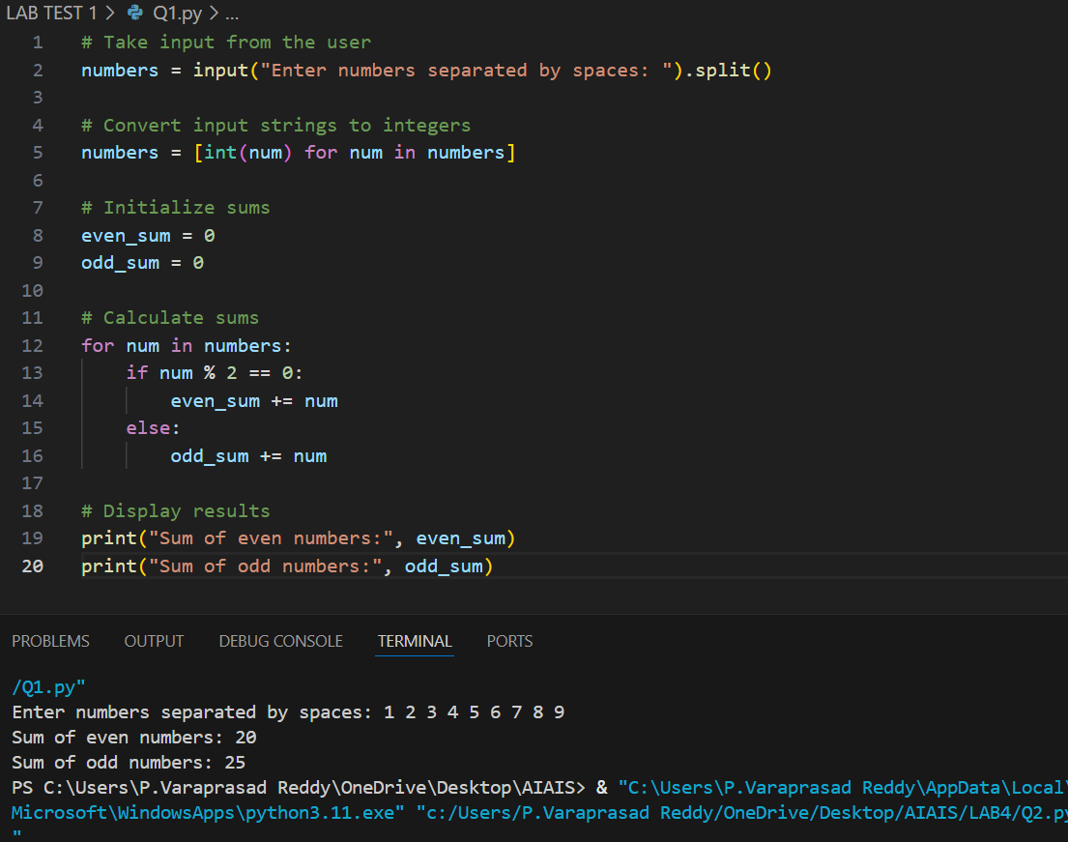

1. Write a Python code for given a list of integers, remove duplicates and print the sorted result. GitHub Copilot along with VS Code. Use one shot prompting.

Prompt2: write a python code that takes input from the user to removes the duplicates and prints the sorted result from a given set of integers .

• Eg: input : 1 1 2 3 4 4

 output: 1 2 3 4

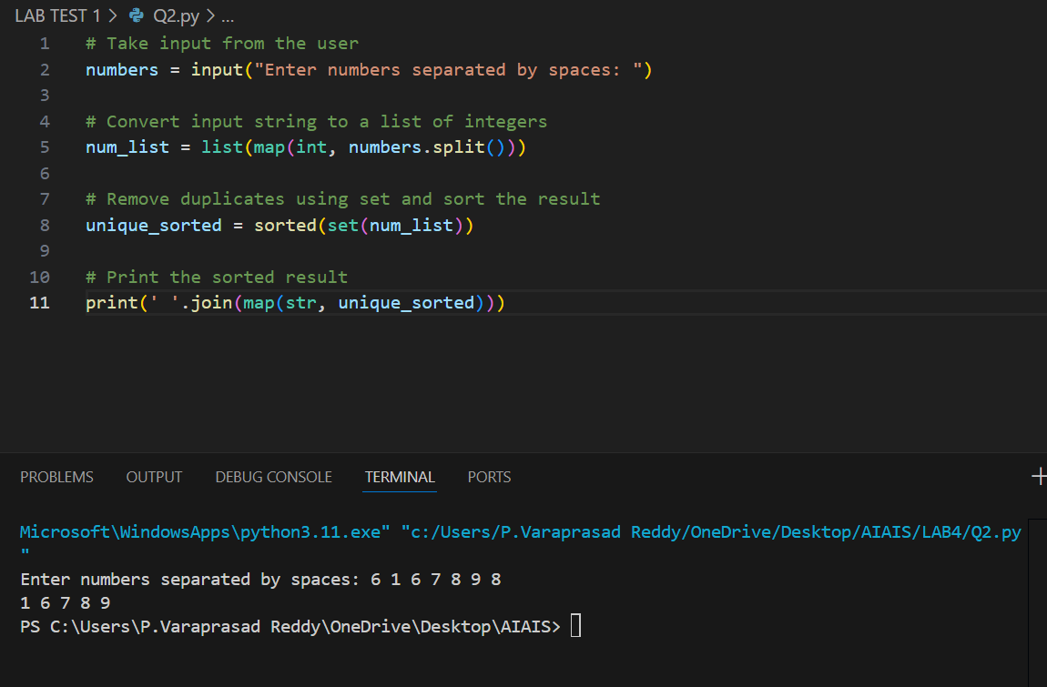

1. Write a Python function that converts the temperature between Celsius, Fahrenheit, and Kelvin based on user choice. Use the Cursor AI tool. Use few shot prompting.

• Prompt 3:write a python code that takes input from user than convert the temperature between celcius ,fahrenhieit and kelvin based user on choice.

Eg1: Choose the conversion you want to perform:

• 1. Celsius to Fahrenheit

• 2. Celsius to Kelvin

• 3. Fahrenheit to Celsius

• 4. Fahrenheit to Kelvin

• 5. Kelvin to Celsius

• 6. Kelvin to Fahrenheit

• Enter your choice (1-6): 1

• Enter temperature in Celsius: 180

180.0 Celsius = 356.0 Fahrenheit

Eg2 : Enter your choice (1-6): 4

Enter temperature in Fahrenheit: 89

89.0 Fahrenheit = 304.81666666666666 Kelvin

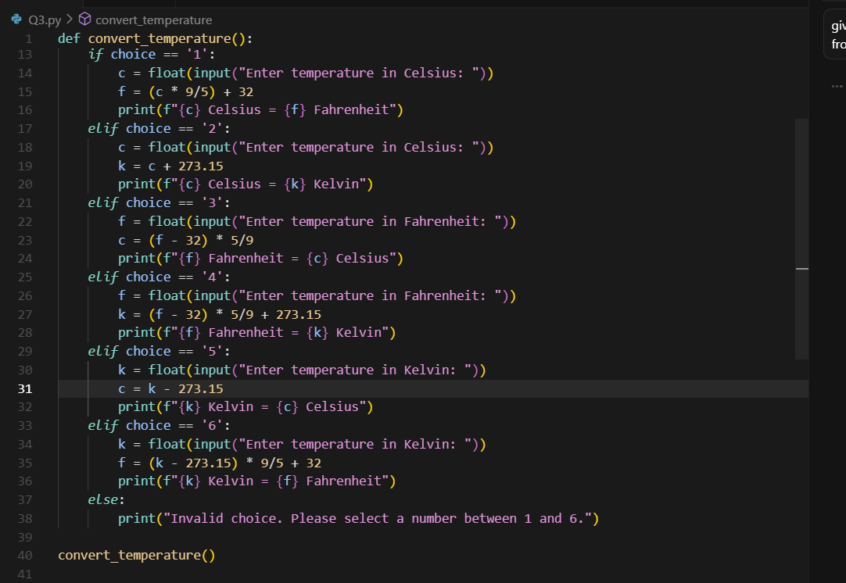

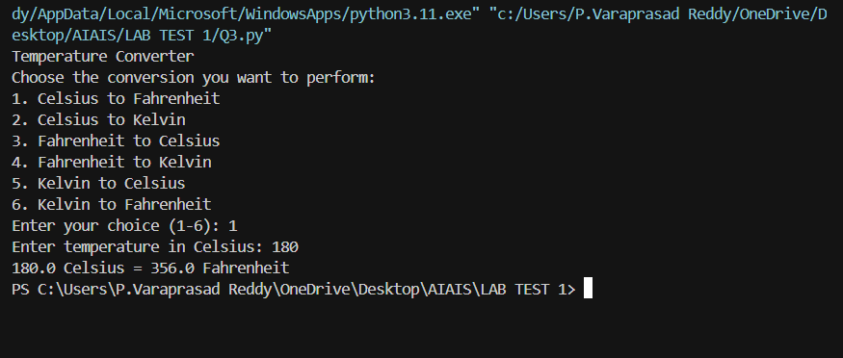

1. Write a Python function to remove punctuation, convert to lowercase, and remove stop words from a given text. Use the Cursor AI tool. Use zero shot prompting.

Prompt 4 :write a python program that takes input from user to remove punctuation, convert to lowercase, and remove stop words from a given text.

